Special Account Claims Affinity Report

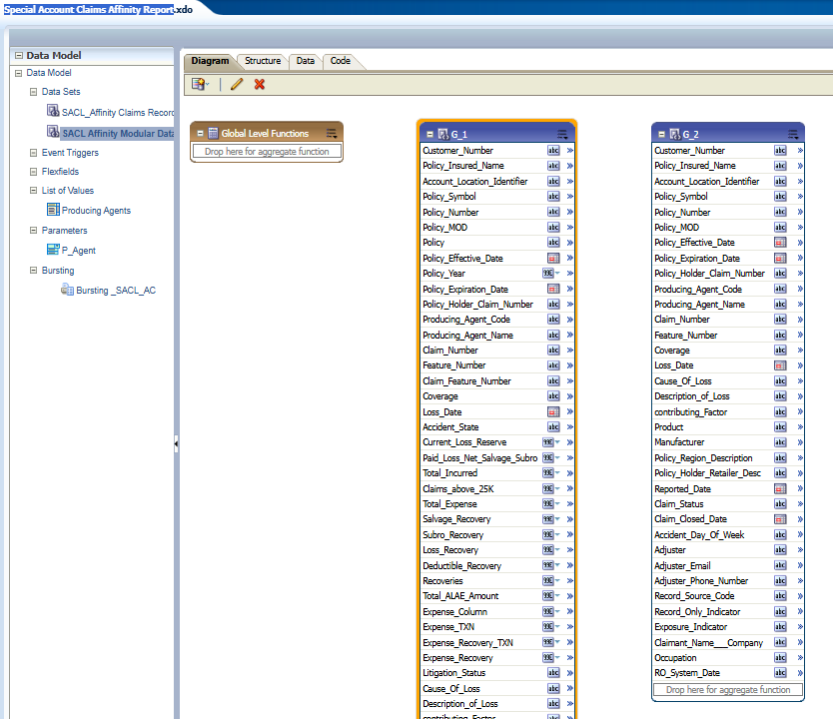
DB details -> jdbc:oracle:thin:@prfinexa.hanover.com:1521/MISP2_S

G1: SQL Code->( SACL Affinity Modular Data Query) – DB: MISP2
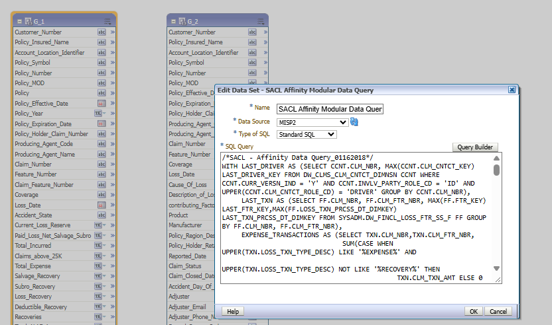
/*SACL - Affinity Data Query_01162018*/
WITH LAST_DRIVER AS (SELECT CCNT.CLM_NBR, MAX(CCNT.CLM_CNTCT_KEY) LAST_DRIVER_KEY FROM DW_CLMS_CLM_CNTCT_DIMNSN CCNT WHERE CCNT.CURR_VERSN_IND = 'Y' AND CCNT.INVLV_PARTY_ROLE_CD = 'ID' AND UPPER(CCNT.CLM_CNTCT_ROLE_CD) = 'DRIVER' GROUP BY CCNT.CLM_NBR),
LAST_TXN AS (SELECT FF.CLM_NBR, FF.CLM_FTR_NBR, MAX(FF.FTR_KEY) LAST_FTR_KEY,MAX(FF.LOSS_TXN_PRCSS_DT_DIMKEY) LAST_TXN_PRCSS_DT_DIMKEY FROM SYSADM.DW_FINCL_LOSS_FTR_SS_F FF GROUP BY FF.CLM_NBR, FF.CLM_FTR_NBR),
EXPENSE_TRANSACTIONS AS (SELECT TXN.CLM_NBR,TXN.CLM_FTR_NBR,
SUM(CASE WHEN UPPER(TXN.LOSS_TXN_TYPE_DESC) LIKE '%EXPENSE%' AND
UPPER(TXN.LOSS_TXN_TYPE_DESC) NOT LIKE '%RECOVERY%' THEN
TXN.CLM_TXN_AMT ELSE 0 END) AS EXPENSE,
SUM(CASE WHEN UPPER(TXN.LOSS_TXN_TYPE_DESC) LIKE '%EXPENSE%' AND
UPPER(TXN.LOSS_TXN_TYPE_DESC) LIKE '%RECOVERY%' THEN
TXN.CLM_TXN_AMT ELSE 0 END) AS EXPENSE_RECOVERY
FROM DW_FINCL_LOSS_TXN_SS_F TXN GROUP BY TXN.CLM_NBR,TXN.CLM_FTR_NBR),
--NET_RECOVRY_AMT AS (SELECT CFF.FTR_KEY,SUM(CFF.EXPNS_PD_NET_RECOVRY_AMT) AS EXPNS_PD_NET_RECOVRY_AMT FROM DW_CLMS_FTR_FACT CFF WHERE CFF.EFF_IND = 0 GROUP BY CFF.FTR_KEY),
LAST_FTR_VERSN AS (SELECT F.CLM_NBR, F.CLM_FTR_NBR, MAX(F.VERSN_BEG_DT) LAST_VERSN FROM DW_CLMS_FTR_DIMNSN F GROUP BY F.CLM_NBR, F.CLM_FTR_NBR),
LAST_LGL AS (SELECT LF.CLM_KEY, LF.FTR_KEY, MAX(LF.CLMS_LGL_KEY) LAST_CLMS_LGL_KEY FROM SYSADM.DW_CLMS_LGL_FACT LF WHERE LF.EFF_IND = 1 GROUP BY LF.CLM_KEY, LF.FTR_KEY),
DATA AS (SELECT
LFIN.CLM_NBR,
FD.CLM_FTR_NBR,
LFIN.LAST_TXN_PRCSS_DT_DIMKEY,
POL.PMS_CUSTMR_NBR,
POL.POL_NAMED_INSRD_TXT,
POL.POL_SYM,
POL.POL_NBR,
POL.POL_MOD,
TRUNC(POL.POL_EFF_DT) POL_EFF_DT,
TRUNC(POL.POL_EXP_DT) POL_EXP_DT,
POL.PRDCNG_AGNT_CD,
RPA.CUR_PA_FULL_NM,
CD.CLM_KEY,
CASE WHEN UPPER(CD.POL_HLDR_CLM_NBR) = 'TRUE' THEN '' ELSE CD.POL_HLDR_CLM_NBR END POL_HLDR_CLM_NBR,
CD.ACCT_LOSS_LOC_ID,
TRUNC(CD.DT_OF_LOSS) DT_OF_LOSS,
LFINCL.MAJ_PERIL_CD,
RMP.MAJ_PERIL_DESC,
LD.LITGTN_STATUS_CD,
LD.LITGTN_STATUS_DESC,
CASE WHEN CD.ACDNT_ST_ABBR <>'!' THEN NVL(CD.ACDNT_ST_ABBR, cd.CLM_JRSDTN_ST_ABBR)
ELSE cd.CLM_JRSDTN_ST_ABBR END ACDNT_ST_ABBR,
CLMNT.CLMNT_FULL_NM,
CLMNT.CLMNT_FIRST_NM,
CLMNT.CLMNT_LAST_NM,
CLMNT.CLMNT_CO_NM,
NVL(CLMNT.OCUPTN_TXT, ' ') OCUPTN_TXT,
LFINCL.CLM_DRVR_KEY,
DRVD.DRV_REL_TO_INSURED_CODE,
(LDRVD.CLM_CNTCT_FIRST_NM || ' ' || LDRVD.CLM_CNTCT_LAST_NM) AS INSURED_DRIVER,
CASE WHEN UPPER(VD.INVLV_VEH_TYPE_CD) = 'INSURED' THEN NVL(VD.VEH_TOTL_LOSS_IND, 'N') END AS VEH_TOTL_LOSS_IND,
CASE WHEN UPPER(VD.INVLV_VEH_TYPE_CD) = 'INSURED' THEN VD.VEH_YEAR END AS VEH_YEAR,
CASE WHEN UPPER(VD.INVLV_VEH_TYPE_CD) = 'INSURED' THEN VD.VEH_MANUFACTURER_CODE END AS VEH_MANUFACTURER_CODE,
CASE WHEN UPPER(VD.INVLV_VEH_TYPE_CD) = 'INSURED' THEN VD.VEH_MODEL END AS VEH_MODEL,
CASE WHEN UPPER(VD.INVLV_VEH_TYPE_CD) = 'INSURED' THEN VD.VEH_VIN_NUMBER END AS VEH_VIN_NUMBER,
CASE WHEN UPPER(VD.INVLV_VEH_TYPE_CD) = 'INSURED' THEN VD.VEH_LICENSE_PLATE END AS VEH_LICENSE_PLATE,
CASE WHEN UPPER(VD.INVLV_VEH_TYPE_CD) = 'INSURED' THEN VD.VEH_REGISTERED_STATE_ABBR END AS VEH_REGISTERED_STATE_ABBR,
UPPER(FD.FTR_ASGNED_USER_FULL_NM) FTR_ASGNED_USER_FULL_NM,
UPPER(FD.FTR_ASGN_USER_EMAIL_ADDR) FTR_ASGN_USER_EMAIL_ADDR,
FD.FTR_ASGN_USER_PHONE_NBR,
CASE WHEN CD.CLM_LOB_CD='wc' THEN CD.AIA_POSTNS_1_AND_2_DESC ELSE CD.CAUSE_OF_LOSS END AS CAUSE_OF_LOSS,--Changed for WC 05252017 KJ
CASE WHEN CD.CLM_LOB_CD='wc' THEN CD.AIA_POSTNS_3_AND_4_DESC ELSE CD.LOSS_DESC END AS LOSS_DESC,--Changed for WC 05252017 KJ
CASE WHEN CD.CLM_LOB_CD='wc' THEN CD.AIA_POSTNS_5_AND_6_DESC ELSE CD.CONTRIBUTING_FCTR END AS CONTRIBUTING_FCTR,--Changed for WC 05252017 KJ
CD.MF_PRODT_DESC,
CD.MF_DESC,
CD.POL_HLDR_RGN_DESC,
CD.POL_HLDR_RETAILER_DESC,
CD.CLM_RPTD_DT,
CD.CLM_STATUS,
CD.CLM_CLOSE_DT,
CD.RCRD_SRC_CD, --WHEN 'Y' THEN MANY FIELDS MAY BE BLANK
CD.INCID_RPT_IND, --WHEN 'Y' THEN FTR_NUMBER MAY BE BLANK
INITCAP(TO_CHAR(CD.DT_OF_LOSS,'DAY')) AS DAY_DT_OF_LOSS,
FD.EXPOSR_IND,
FD.FTR_TYPE_CD,
FD.FTR_TYPE_DESC,
FD.FTR_COVG_TYPE_CD,
FD.FTR_COVG_TYPE_DESC,
NVL(FINCL.FTR_CHNG_IN_OSLS_AMT, 0) FTR_CHNG_IN_OSLS_AMT,
NVL(FINCL.FTR_PDLS_INCL_SLVG_SUBRO_AMT, 0) FTR_PDLS_INCL_SLVG_SUBRO_AMT,
NVL(FINCL.FTR_SLVG_AMT, 0) FTR_SLVG_AMT,
NVL(FINCL.FTR_SUBRO_AMT, 0) FTR_SUBRO_AMT,
NVL(FINCL.LOSS_RECOVRY_AMT,0) LOSS_RECOVRY_AMT,
NVL(FINCL.DEDTBL_RECOVRY_AMT, 0) DEDTBL_RECOVRY_AMT,
NVL(FINCL.FTR_ALAE_AMT, 0) FTR_ALAE_AMT,--/*Total amount of loss expense payments for the feature including expense recoveries.*/
NVL(ETXN.EXPENSE,0) AS EXPENSE,
NVL(ETXN.EXPENSE_RECOVERY,0) AS EXPENSE_RECOVERY,
-- NVL(nra.EXPNS_PD_NET_RECOVRY_AMT, 0) FTR_ALAE_AMT1,/*Total amount of loss expense payments for the feature excluding expense recoveries.*/
NVL(FINCL.FTR_ALAE_AMT-FINCL.expnse_recovry_amt, 0) FTR_ALAE_AMT2,
NVL(FINCL.expnse_recovry_amt, 0) expnse_recovry_amt,
NVL(FINCL.FTR_INCUR_INCL_SLVG_SUBRO_AMT, 0) FTR_INCUR_INCL_SLVG_SUBRO_AMT,
NVL(FINCL.FTR_PDLS_EXCL_SLVG_SUBRO_AMT, 0) FTR_PDLS_EXCL_SLVG_SUBRO_AMT,
FD.CURR_VERSN_IND
FROM
LAST_TXN LFIN
INNER JOIN SYSADM.DW_FINCL_LOSS_FTR_SS_F LFINCL ON LFIN.CLM_NBR = LFINCL.CLM_NBR AND LFIN.CLM_FTR_NBR = LFINCL.CLM_FTR_NBR AND LFIN.LAST_TXN_PRCSS_DT_DIMKEY = LFINCL.LOSS_TXN_PRCSS_DT_DIMKEY
INNER JOIN DW_CLMS_CLM_DIMNSN CD ON LFIN.CLM_NBR = CD.CLM_NBR AND CD.CURR_VERSN_IND = 'Y'
LEFT OUTER JOIN LAST_FTR_VERSN LV ON LFIN.CLM_NBR = LV.CLM_NBR AND LFIN.CLM_FTR_NBR = lv.CLM_FTR_NBR
LEFT OUTER JOIN DW_CLMS_FTR_DIMNSN FD ON LFIN.CLM_NBR = FD.CLM_NBR AND LFIN.CLM_FTR_NBR = FD.CLM_FTR_NBR AND FD.CURR_VERSN_IND = 'Y' AND TRUNC(FD.VERSN_BEG_DT) = TRUNC(lv.last_VERSN)--LFINCL.FTR_KEY = FD.FTR_KEY
-- LEFT OUTER JOIN NET_RECOVRY_AMT NRA ON FD.FTR_KEY = NRA.FTR_KEY
INNER JOIN SYSADM.DW_POL_DIMNSN POL ON CD.POL_SYM = POL.POL_SYM AND CD.POL_NBR = POL.POL_NBR AND CD.POL_MOD = POL.POL_MOD AND POL.POL_CURR_VERSN_IND = 'Y'
LEFT OUTER JOIN LAST_LGL LL ON LFINCL.CLM_KEY = LL.CLM_KEY AND LFINCL.FTR_KEY = LL.FTR_KEY
LEFT OUTER JOIN SYSADM.DW_CLMS_LGL_FACT LF ON LFINCL.FTR_KEY = LF.FTR_KEY AND LFINCL.CLM_KEY = LF.CLM_KEY AND LF.CLMS_LGL_KEY = LL.LAST_CLMS_LGL_KEY
LEFT OUTER JOIN SYSADM.DW_CLMS_LGL_DIMNSN LD ON LF.CLMS_LGL_KEY = LD.CLMS_LGL_KEY
LEFT OUTER JOIN SYSADM.DM_RETNTN_PRDCNG_AGNT_HR_D RPA ON POL.PRDCNG_AGNT_CD = RPA.CUR_ENTR_PA_CD
-- LEFT OUTER JOIN SYSADM.DW_CLMS_INCID_LOC_DIMNSN INCID ON --LFINCL.INCID_KEY = INCID.INCID_KEY
LEFT OUTER JOIN SYSADM.DW_CLMS_CLMNT_DIMNSN CLMNT ON LFINCL.CLMNT_KEY = CLMNT.CLMNT_KEY
LEFT OUTER JOIN SYSADM.DW_CLMS_DRVR_DIMNSN DRVD ON LFINCL.CLM_DRVR_KEY = DRVD.CLM_DRVR_KEY
LEFT OUTER JOIN LAST_DRIVER LDRD ON LFINCL.CLM_NBR = LDRD.CLM_NBR
LEFT OUTER JOIN DW_CLMS_CLM_CNTCT_DIMNSN LDRVD ON LDRVD.CLM_NBR = LDRD.CLM_NBR AND LDRVD.CLM_CNTCT_KEY = LDRD.LAST_DRIVER_KEY
LEFT OUTER JOIN SYSADM.DW_CLMS_VEH_DIMNSN VD ON LFINCL.VEH_KEY = VD.VEH_DIMKEY AND VD.CURR_VERSN_IND = 'Y'
LEFT OUTER JOIN DW_REF_MAJ_PERIL RMP ON LFINCL.MAJ_PERIL_CD = RMP.MAJ_PERIL_CD AND TRUNC(LFINCL.RCRD_INSRT_DT) BETWEEN TRUNC(RMP.VERSN_BEG_DT) AND TRUNC(RMP.VERSN_END_DT)
LEFT OUTER JOIN SYSADM.DW_FINCL_LOSS_FTR_SS_F FINCL ON LFINCL.CLM_NBR = FINCL.CLM_NBR AND LFINCL.CLM_FTR_NBR = FINCL.CLM_FTR_NBR
LEFT OUTER JOIN EXPENSE_TRANSACTIONS ETXN ON LFINCL.CLM_NBR = ETXN.CLM_NBR AND LFINCL.CLM_FTR_NBR = ETXN.CLM_FTR_NBR

WHERE
UPPER(NVL(CD.ACCT_LOSS_LOC_ID, 'NA')) NOT LIKE '%REKEY%' AND
NVL(CD.INCID_RPT_IND, 'N') = 'N' AND
NVL(FD.EXPOSR_IND, 'N') = 'N'
--AND LFIN.CLM_NBR in ('14-00723387')
AND POL.PRDCNG_AGNT_CD in (:P_Agent)
--AND CD.SPCL_ACCT_IND='Y'
--POL.PMS_CUSTMR_NBR IN ('0019463319')--Uno
)
SELECT
D.PMS_CUSTMR_NBR AS "Customer Number",
D.POL_NAMED_INSRD_TXT AS "Policy Insured Name",
D.ACCT_LOSS_LOC_ID AS "Account Location Identifier",
D.POL_SYM AS "Policy Symbol",
D.POL_NBR AS "Policy Number",
D.POL_MOD AS "Policy MOD",
(D.POL_SYM||'-'||D.POL_NBR||'-'||D.POL_MOD) AS "Policy",
D.POL_EFF_DT AS "Policy Effective Date",
EXTRACT(YEAR FROM D.POL_EFF_DT) AS "Policy Year",
D.POL_EXP_DT AS "Policy Expiration Date",
D.POL_HLDR_CLM_NBR AS "Policy Holder Claim Number",
D.PRDCNG_AGNT_CD AS "Producing Agent Code",
D.CUR_PA_FULL_NM AS "Producing Agent Name",
D.CLM_NBR AS "Claim Number",
D.CLM_FTR_NBR AS "Feature Number",
(D.CLM_NBR || D.CLM_FTR_NBR) AS "Claim Feature Number",
--D.MAJ_PERIL_DESC AS "Coverage A",--Remove this column
--D.FTR_TYPE_DESC AS "Coverage B",--Remove this column
D.FTR_COVG_TYPE_DESC AS "Coverage",
D.DT_OF_LOSS AS "Loss Date",
D.ACDNT_ST_ABBR AS "Accident State",
SUM(D.FTR_CHNG_IN_OSLS_AMT) AS "Current Loss Reserve",
(SUM(D.FTR_PDLS_INCL_SLVG_SUBRO_AMT)-sum(d.DEDTBL_RECOVRY_AMT)) AS "Paid Loss Net Salvage Subro",
(SUM(d.FTR_INCUR_INCL_SLVG_SUBRO_AMT)-sum(d.DEDTBL_RECOVRY_AMT)) AS "Total Incurred",
CASE WHEN SUM(D.FTR_INCUR_INCL_SLVG_SUBRO_AMT) > 25000 THEN 1 ELSE 0 END AS "Claims above 25K",
--max(Ftr_ALAE_Adjusted) as Ftr_ALAE_Adjusted,
--max(Ftr_ALAE_Recovery) as Ftr_ALAE_Recovery,
CASE WHEN NVL(sum(D.FTR_ALAE_AMT2), 0) = 0 THEN SUM(D.FTR_ALAE_AMT) ELSE sum(D.FTR_ALAE_AMT2) END AS "Total Expense",
SUM(D.FTR_SLVG_AMT) AS "Salvage Recovery",
SUM(D.FTR_SUBRO_AMT) AS "Subro Recovery",
SUM(D.LOSS_RECOVRY_AMT) AS "Loss Recovery",
SUM(d.DEDTBL_RECOVRY_AMT) AS "Deductible Recovery",
(SUM(D.FTR_SLVG_AMT)+SUM(D.FTR_SUBRO_AMT)+SUM(D.DEDTBL_RECOVRY_AMT)) AS "Recoveries",
SUM(D.FTR_ALAE_AMT) AS "Total ALAE Amount", --Remove this column
NVL(sum(D.FTR_ALAE_AMT2), 0) AS "Expense Column", --Remove this column,--Added as part of HCS Financials project 04/2020
MAX(D.EXPENSE) AS "Expense TXN",
sum(D.EXPENSE_RECOVERY) AS "Expense Recovery TXN",
NVL(sum(D.expnse_recovry_amt), 0) AS "Expense_Recovery",--Added as part of HCS Financials project 04/2020
D.LITGTN_STATUS_DESC AS "Litigation Status", --Possible Duplicate Issue - Open HTG
D.CAUSE_OF_LOSS AS "Cause Of Loss",
D.LOSS_DESC AS "Description of Loss",
D.CONTRIBUTING_FCTR AS "contributing Factor",
D.MF_PRODT_DESC AS "Product",
D.MF_DESC AS "Manufacturer",
D.POL_HLDR_RGN_DESC AS "Policy Region Description",
D.POL_HLDR_RETAILER_DESC AS "Policy Holder Retailer Desc",
D.CLM_RPTD_DT AS "Reported Date",
D.CLM_STATUS AS "Claim Status",
D.CLM_CLOSE_DT AS "Claim Closed Date",
(D.CLMNT_FULL_NM || D.CLMNT_CO_NM) AS "Claimant Name - Company",
D.CLMNT_FIRST_NM,
D.CLMNT_LAST_NM,
D.CLMNT_FULL_NM,
D.CLMNT_CO_NM,
D.OCUPTN_TXT AS "Occupation",
D.DAY_DT_OF_LOSS AS "Accident Day Of Week",
D.INSURED_DRIVER AS "Insured Driver",
D.VEH_TOTL_LOSS_IND AS "Total Loss Indicator",
D.VEH_YEAR AS "Vehicle Year",
D.VEH_MANUFACTURER_CODE AS "Vehicle Manufacturer",
D.VEH_MODEL AS "Vehicle Model",
D.VEH_VIN_NUMBER AS "Vehicle ID Number",
D.VEH_LICENSE_PLATE AS "Vehicle License Plate",
D.VEH_REGISTERED_STATE_ABBR AS "Vehicle License State",
D.FTR_ASGNED_USER_FULL_NM AS "Adjuster",
D.FTR_ASGN_USER_EMAIL_ADDR AS "Adjuster Email",
D.FTR_ASGN_USER_PHONE_NBR AS "Adjuster Phone Number",
D.RCRD_SRC_CD AS "Record Source Code",
D.INCID_RPT_IND AS "Record Only Indicator",
D.EXPOSR_IND AS "Exposure Indicator",
D.CURR_VERSN_IND "Current Version IND",
TO_CHAR(TRUNC(SYSDATE),'MM/DD/YYYY') AS "System Date"
FROM
DATA D
GROUP BY
D.PMS_CUSTMR_NBR,
D.POL_NAMED_INSRD_TXT,
D.ACCT_LOSS_LOC_ID,
D.POL_SYM,
D.POL_NBR,
D.POL_MOD,
D.POL_EFF_DT,
D.POL_EXP_DT,
D.POL_HLDR_CLM_NBR,
D.PRDCNG_AGNT_CD,
D.CUR_PA_FULL_NM,
D.CLM_NBR,
D.CLM_FTR_NBR,
D.MAJ_PERIL_DESC,
D.FTR_TYPE_DESC,
D.FTR_COVG_TYPE_DESC,
D.DT_OF_LOSS,
D.ACDNT_ST_ABBR,
D.LITGTN_STATUS_DESC,
D.CAUSE_OF_LOSS,
D.LOSS_DESC,
D.CONTRIBUTING_FCTR,
D.MF_PRODT_DESC,
D.MF_DESC,
D.POL_HLDR_RGN_DESC,
D.POL_HLDR_RETAILER_DESC,
D.CLM_RPTD_DT,
D.CLM_STATUS,
D.CLM_CLOSE_DT,
(D.CLMNT_FULL_NM || D.CLMNT_CO_NM),
D.CLMNT_FIRST_NM,
D.CLMNT_LAST_NM,
D.CLMNT_FULL_NM,
D.CLMNT_CO_NM,
D.OCUPTN_TXT,
D.DAY_DT_OF_LOSS,
D.INSURED_DRIVER,
d.CLM_DRVR_KEY,
d.DRV_REL_TO_INSURED_CODE,
D.VEH_TOTL_LOSS_IND,
D.VEH_YEAR,
D.VEH_MANUFACTURER_CODE,
D.VEH_MODEL,
D.VEH_VIN_NUMBER,
D.VEH_LICENSE_PLATE,
D.VEH_REGISTERED_STATE_ABBR,
D.FTR_ASGNED_USER_FULL_NM,
D.FTR_ASGN_USER_EMAIL_ADDR,
D.FTR_ASGN_USER_PHONE_NBR,
D.RCRD_SRC_CD,
D.INCID_RPT_IND,
D.EXPOSR_IND,
d.CURR_VERSN_IND
HAVING
((D.CLM_STATUS in ('Closed','closed') AND extract(year from D.POL_EFF_DT) >=extract(year from add_months(sysdate,-60)))
OR SUM(D.FTR_CHNG_IN_OSLS_AMT) > 0
OR D.CLM_STATUS in ('Open','open'))
ORDER BY D.CLM_NBR,D.CLM_FTR_NBR

G2-> SQL Code: SACL_Affinity Claims Records Only :: DB- MISP2
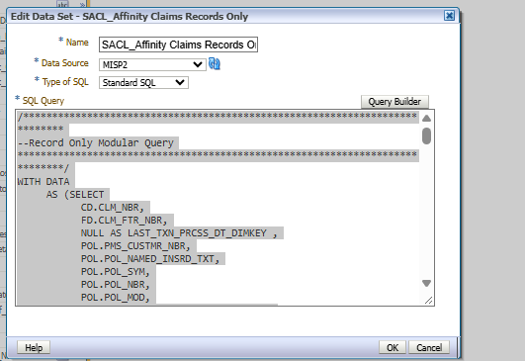
/****************************************************************************
--Record Only Modular Query
*****************************************************************************/
WITH DATA
AS (SELECT
CD.CLM_NBR,
FD.CLM_FTR_NBR,
NULL AS LAST_TXN_PRCSS_DT_DIMKEY ,
POL.PMS_CUSTMR_NBR,
POL.POL_NAMED_INSRD_TXT,
POL.POL_SYM,
POL.POL_NBR,
POL.POL_MOD,
TRUNC(POL.POL_EFF_DT) POL_EFF_DT,
TRUNC(POL.POL_EXP_DT) POL_EXP_DT,
POL.PRDCNG_AGNT_CD,
RPA.CUR_PA_FULL_NM,
CD.CLM_KEY,
CASE
WHEN UPPER(CD.POL_HLDR_CLM_NBR) = 'TRUE' THEN ''
ELSE CD.POL_HLDR_CLM_NBR
END
POL_HLDR_CLM_NBR,
CD.ACCT_LOSS_LOC_ID,
TRUNC(CD.DT_OF_LOSS) DT_OF_LOSS,
FD.FTR_ASGNED_USER_FULL_NM,
FD.FTR_ASGN_USER_EMAIL_ADDR,
FD.FTR_ASGN_USER_PHONE_NBR,
CD.CAUSE_OF_LOSS,
CD.LOSS_DESC,
CD.CONTRIBUTING_FCTR,
CD.MF_PRODT_DESC,
CD.MF_DESC,
CD.POL_HLDR_RGN_DESC,
CD.POL_HLDR_RETAILER_DESC,
CD.CLM_RPTD_DT,
CD.CLM_STATUS,
CD.CLM_CLOSE_DT,
CD.RCRD_SRC_CD, --When 'Y' then many fields may be blank
CD.INCID_RPT_IND, --When 'Y' then Ftr_Number may be blank
INITCAP(TO_CHAR(CD.DT_OF_LOSS,'DAY')) AS DAY_DT_OF_LOSS,
FD.EXPOSR_IND,
FD.FTR_TYPE_CD,
FD.FTR_TYPE_DESC,
FD.FTR_COVG_TYPE_CD,
FD.FTR_COVG_TYPE_DESC,
CLMNT.CLMNT_FULL_NM,
CLMNT.CLMNT_CO_NM,
NVL(CLMNT.OCUPTN_TXT, ' ') OCUPTN_TXT
FROM
SYSADM.DW_POL_DIMNSN POL
INNER JOIN DW_CLMS_CLM_DIMNSN CD ON POL.POL_SYM = CD.POL_SYM AND POL.POL_NBR = CD.POL_NBR AND POL.POL_MOD = CD.POL_MOD AND CD.CURR_VERSN_IND = 'Y'
LEFT OUTER JOIN DW_CLMS_FTR_DIMNSN FD ON CD.CLM_NBR = FD.CLM_NBR AND FD.CURR_VERSN_IND = 'Y'
LEFT OUTER JOIN SYSADM.DM_RETNTN_PRDCNG_AGNT_HR_D RPA ON POL.PRDCNG_AGNT_CD = RPA.CUR_ENTR_PA_CD
--left outer JOIN DW_CLMS_FTR_FACT FF ON CD.CLM_KEY = FF.CLM_KEY AND FD.FTR_KEY=FF.FTR_KEY AND FF.EFF_IND = 0
LEFT OUTER JOIN DW_CLMS_CLMNT_DIMNSN CLMNT ON CLMNT.CLMNT_HCS_SYS_ID = FD.CLMNT_HCS_SYS_ID AND CLMNT.CURR_VERSN_IND='Y'
WHERE CD.INCID_RPT_IND = 'Y'
AND UPPER(NVL(CD.ACCT_LOSS_LOC_ID, 'NA')) NOT LIKE '%REKEY%'
AND POL.PRDCNG_AGNT_CD in (:P_Agent)

AND POL.POL_CURR_VERSN_IND = 'Y'
--AND CD.SPCL_ACCT_IND='Y'
AND TRUNC(POL.POL_EFF_DT) > ADD_MONTHS(TRUNC(SYSDATE,'YEAR'),(-72))
AND NOT EXISTS (SELECT 1 FROM SYSADM.DW_FINCL_LOSS_FTR_SS_F FINCL WHERE
--FINCL.CURR_EFF_IND = 0 AND
FINCL.CLM_NBR = CD.CLM_NBR AND FINCL.CLM_FTR_NBR=FD.CLM_FTR_NBR))
SELECT
D.PMS_CUSTMR_NBR AS "Customer Number",
D.POL_NAMED_INSRD_TXT AS "Policy Insured Name",
D.ACCT_LOSS_LOC_ID AS "Account Location Identifier",
D.POL_SYM AS "Policy Symbol",
D.POL_NBR AS "Policy Number",
D.POL_MOD AS "Policy MOD",
D.POL_EFF_DT AS "Policy Effective Date",
D.POL_EXP_DT AS "Policy Expiration Date",
D.POL_HLDR_CLM_NBR AS "Policy Holder Claim Number",
D.PRDCNG_AGNT_CD AS "Producing Agent Code",
D.CUR_PA_FULL_NM AS "Producing Agent Name",
D.CLM_NBR AS "Claim Number",
D.CLM_FTR_NBR AS "Feature Number",
D.FTR_COVG_TYPE_DESC AS "Coverage",
D.DT_OF_LOSS AS "Loss Date",
D.CAUSE_OF_LOSS AS "Cause Of Loss",
D.LOSS_DESC AS "Description of Loss",
D.CONTRIBUTING_FCTR AS "contributing Factor",
D.MF_PRODT_DESC AS "Product",
D.MF_DESC AS "Manufacturer",
D.POL_HLDR_RGN_DESC AS "Policy Region Description",
D.POL_HLDR_RETAILER_DESC AS "Policy Holder Retailer Desc",
D.CLM_RPTD_DT AS "Reported Date",
D.CLM_STATUS AS "Claim Status",
D.CLM_CLOSE_DT AS "Claim Closed Date",
D.DAY_DT_OF_LOSS AS "Accident Day Of Week",
D.FTR_ASGNED_USER_FULL_NM AS "Adjuster",
D.FTR_ASGN_USER_EMAIL_ADDR AS "Adjuster Email",
D.FTR_ASGN_USER_PHONE_NBR AS "Adjuster Phone Number",
D.RCRD_SRC_CD AS "Record Source Code",
D.INCID_RPT_IND AS "Record Only Indicator",
D.EXPOSR_IND AS "Exposure Indicator",
TO_CHAR(TRUNC(SYSDATE),'MM/DD/YYYY') AS "RO System Date",
(D.CLMNT_FULL_NM || D.CLMNT_CO_NM) AS "Claimant Name - Company",
D.OCUPTN_TXT AS "Occupation"
FROM
DATA D
GROUP BY
D.PMS_CUSTMR_NBR,
D.POL_NAMED_INSRD_TXT,
D.ACCT_LOSS_LOC_ID,
D.POL_SYM,
D.POL_NBR,
D.POL_MOD,
D.POL_EFF_DT,
D.POL_EXP_DT,
D.POL_HLDR_CLM_NBR,
D.PRDCNG_AGNT_CD,
D.CUR_PA_FULL_NM,
D.CLM_NBR,
D.CLM_FTR_NBR,
D.FTR_TYPE_DESC,
D.FTR_COVG_TYPE_DESC,
D.DT_OF_LOSS,
D.CAUSE_OF_LOSS,
D.LOSS_DESC,
D.CONTRIBUTING_FCTR,
D.MF_PRODT_DESC,
D.MF_DESC,
D.POL_HLDR_RGN_DESC,
D.POL_HLDR_RETAILER_DESC,
D.CLM_RPTD_DT,
D.CLM_STATUS,
D.CLM_CLOSE_DT,
D.DAY_DT_OF_LOSS,
D.FTR_ASGNED_USER_FULL_NM,
D.FTR_ASGN_USER_EMAIL_ADDR,
D.FTR_ASGN_USER_PHONE_NBR,
D.RCRD_SRC_CD,
D.INCID_RPT_IND,
D.EXPOSR_IND,
D.CLMNT_FULL_NM,
D.CLMNT_CO_NM,
D.OCUPTN_TXT
ORDER BY
D.PMS_CUSTMR_NBR,
D.CLM_NBR,
D.CLM_FTR_NBR

